SIMATS ENGINEERING (SAVEETHA SCHOOL OF ENGINEERING)

Department of Computer Science and Engineering

ASSESSMENT TOOL 3 – TECHNICAL PRESENTATION

Course Code: | CSA06 | Course Title: | Design and Analysis of Algorithms
CO Assessed: | CO1 – Precision (BL1, BL2, BL3) | Assessment: | Assessment Tool 3 – Technical Presentation
Weightage: | 10% of CIA | Total Marks: | 100
CO1 Statement: | Determine algorithm efficiency using asymptotic notations and mathematical techniques including Master Theorem and substitution method. (BL1, BL2, BL3)
Student Name: | Kishore Gadhi | Reg. No.: | 192365051
Section / Batch: | CSE(Cyber Security) | Date:
Instructions to Students
- Answer the given question through a technical presentation. Total Marks: 100.
- Clearly define the problem and explain the concept of algorithm growth functions.
- Present comparative analysis using appropriate representations such as graphs, tables, or charts.
- Use suitable tools (PowerPoint, visualization tools, or software) to support your explanation.
- Ensure technical accuracy, logical flow, and proper interpretation of results.
- Maintain clarity in communication, proper slide organization, and professional delivery.
- Time management, confidence, and audience engagement will be considered during evaluation.

Question Type | Focus Area | Questions
Technical Presentation | Analyze and compare growth functions using mathematical techniques and asymptotic concepts and with graphical and visual interpretation | Q1

SECTION A – Technical Presentation

Master Theorem Application for Equal Growth Case

Consider the recurrence relation T(n) = 2T(n/2) + n. Analyze the problem using the Master Theorem and determine its time complexity. Clearly identify the values of a, b, and f(n), and compare f(n) with n^log_b a. Justify the selected case step-by-step and explain why it belongs to the equal-growth category. Use recursion tree support if needed and present the final result with proper interpretation.

Code of Conduct
I Kishore Gadh i(Name / Reg No) certify that this submission is my original work and that I have adhered to the guidelines specified for this assessment. I understand that any violation of academic integrity rules will result in disciplinary action.
Signature of the Student:

RUBRICS FOR CALCULATION

Criteria | Wt. | Level 4 – Exemplary | Level 3 – Proficient | Level 2 – Developing | Level 1 – Beginning
Technical Content Accuracy | 30% | Highly accurate, in-depth, and insightful technical explanation | Technically correct content with adequate depth and clarity | Basic concepts presented with limited accuracy and depth | Content contains major technical errors; concepts poorly understood
Problem Identificat ion | 25% | Problem rigorously analyzed using appropriate and advanced methods | Problem clearly defined with a logical engineering approach | Problem identified but analysis or methodology is weak | Problem statement unclear or incorrect; no logical approach
Use of Tools | 20% | Advanced tools, well-analyzed data, and highly effective visuals | Appropriate tools and data used effectively with clear visuals | Limited use of tools and basic data interpretation | Minimal or incorrect use of tools and data; poor visuals
Communi cation | 15% | Highly engaging, confident, and audience-focused delivery | Clear, organized, and professional communication | Understandable but lacks clarity, structure, or confidence | Poor organization, unclear speech, ineffective slides
Professio nalism | 10% | Exemplary professionalism, leadership, and ethical awareness | Professional conduct with effective team collaboration | Basic professionalism; uneven team participation | Lacks professionalism; minimal contribution or ethical awareness

Marks Evaluation:
Criteria | Wt. | Level 4 – Exemplary | Level 3 – Proficient | Level 2 – Developing | Level 1 – Beginning
Technical Content Accuracy | 30%
Problem Identification | 25%
Use of Tools | 20%
Communication | 15%
Professionalism | 10%
Total Marks (100):

Faculty In-charge | Course Coordinator | Head of Department
Name: | Name: | Name:
Signature: | Signature: | Signature:
Date: | Date: | Date:

Master Theorem Application for Equal Growth Case

Consider the recurrence relation T(n) = 2T(n/2) + n. Analyze the problem using the Master Theorem and determine its time complexity. Clearly identify the values of a, b, and f(n), and compare f(n) with n^log_b a. Justify the selected case step-by-step and explain why it belongs to the equal-growth category. Use recursion tree support if needed and present the final result with proper interpretation.

Geo Tag Photo:

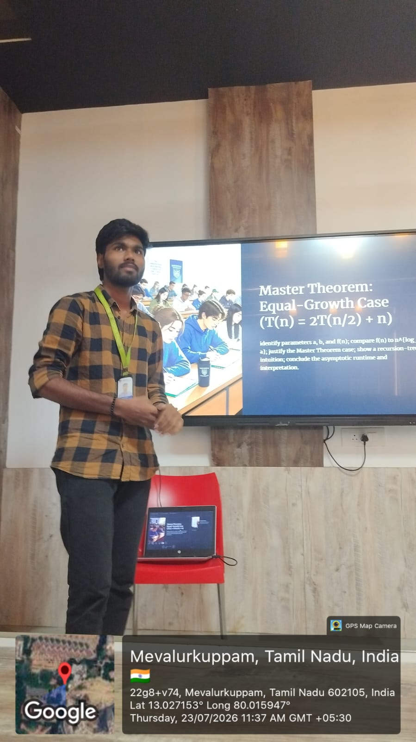

Presentation :

